Journal #2

Feminist in History: Mary Daly

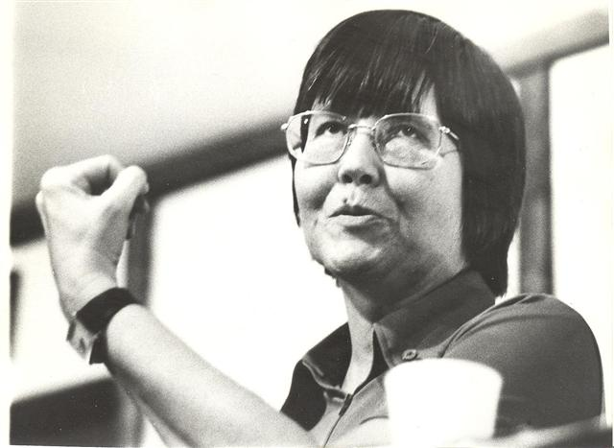

Mary Daly was born in October of 1928 in Schenectady, New York. Being raised in New York around that time period, it is more than known that Daly was raised in a very Catholic family with strict views and confiding rules. Daly never questioned her religion as a young girl or in the beginning of her long higher level education. She even began her bachelor’s degree in English and Latin from the College of Saint Rose in Albany, New York in 1950, a catholic college. She continued her education at a catholic institution, specifically The Catholic University of America obtaining her master’s degree in English shortly afterwards. Daly valued education tremendously and therefore decided to continue her journey of higher knowledge obtaining a Ph.D. in theology from Saint Mary’s College in Notre Dame, Indiana. This step alone was leading her into later becoming a feminist because she was one of the first women to train as a roman catholic theologian, already challenging the status quo. At this point in Daly’s life she has begun to focus her studies in a women-centered manner and decided to leave her faith behind as she headed to Switzerland to further her education and obtain two more doctorate degrees in philosophy and theology from the University of Fribourg.

Daly began teaching as a professor at Boston College in 1966, she specialized in courses of theology, feminist ethics, and patriarchy. This soon lead to her completing and publishing her first book just three years after beginning her professorship at Boston College. With her strong background in English, naturally Daly was an excellent writer and began to publish the first of her many books to come in the future. By 1968, just eighteen years after beginning her higher level education, Daly published her first book, “The Church and the Second Sex”, in which she argued the churches position was against women, maintaining their oppression for centuries. Obviously, coming from a long background of Catholicism in her family and educational life, this publishing caused an uprising from many people in and around Daly’s life. With the publishing of this novel it becomes more than apparent that Daly is not a fan of the patriarchy or the men who continually abuse it. She uses religion as a first step into her discussion about the patriarchy. Regardless of the controversy this publishing caused, “Many feminists would regard her as a (some would say *the*) ‘foremother’ of their enterprise” (King, 40). King’s interpretation of Daly was more than spot on as many feminists who later studied the same materials reference Daly again and again.

At this point in her life, Daly has come to terms with no longer identifying as a Catholic and otherwise despising organized religion, she even refers to herself as ‘post-Christian’. She later published her second book, “Beyond God the Father: Toward a philosophy of Women’s Liberation”, in which she continued the conversation of patriarchy in religion and more generally, misogyny in religion. Even in interviews, Daly was very open about her views, putting them in simple yet controversial terms saying “woman’s asking for equality in the church would be comparable to a black person’s demanding equality in the Ku Klux Klan” (King). This comparison stood out to many people allowing some form of insight into Daly’s perceptions of religion. Even further, in Daly’s first novel she focuses a large portion on the Old Testament and New Testament and how they refer to women as “inferior beings” (Daly, 75). Her views on religion maintained very clear throughout her feminist journey, but her views on equality between the sexes, or feminism, can be blurred from time to time. In an interview Daly says, “I don't think about men. I really don't care about them. I'm concerned with women's capacities, which have been infinitely diminished under patriarchy. Not that they've disappeared, but they've been made subliminal. I'm concerned with women enlarging our capacities, actualizing them. So that takes all my energy” (Bridle). She went on in the same interview to talk about the continuation of life on Earth and that if that continuation is to happen then there must be a reduction in the male population. This disregard and almost hatred for men doesn’t end here as she continues her job at Boston College and faces controversy with male students.

At Boston College Daly taught both lower level and upper level courses in feminist ethics and patriarchy, but it is very well known that in her upper level feminist courses, Daly discriminated against male students, not allowing them to join the classes. Referring to herself as a ‘radical lesbian feminist’, it is not surprising that Daly limited male access to higher level feminist courses. She maintained her stance against men joining these classes saying, “the presence of men there would inhibit frank discussion”, not allowing the full conversation to be held. Daly wasn’t a complete anti-man feminist though, she allowed men to participate in her lower level courses and if any men were interested in learning about higher level feminism, she would offer to private tutor just about any student on those subjects. This hatred towards men came back to her eventually in 1999 when a male student threatened to sue her and the school for denying him a place in her class on feminist ethics. This controversy ended in the retirement of Daly in 1999 after working at Boston College for 33 years. This retirement has controversy within itself because the college claims that Daly and themselves came to an agreement about her retirement while Daly holds her stance that she was forced against her will to retire from her long held position.

In 2010, Daly died at the age of 81 after experiencing declining health just before her death. Her mark on the world was rather large despite her presence no longer being on this earth. She was attributed with encouraging women of all religions to speak out and do their own studies and searching. “Even those who disagreed with her respected the fact that Mary Daly was unafraid to raise hard questions and offer unpopular answers” (Hunt, 7). This ability to be a radical feminist even if nobody else was evolved into Daly holding a long respected position among feminists and non-feminists alike. To this day her legacy leads on through the studies of radical feminism, her books, and the students who learned from her.

Citations:

Hunt, Mary E. "On Mary Daly." *Journal of Feminist Studies in Religion* 26.2 (Fall 2010): 7-9. *JSTOR [JSTOR]*. Web. 10 Sept. 2016.

King, Nicholas. "Some Feminist Religious Thinkers." *Whispers of Liberation: Feminist Perspectives on the New Testament*. New York: Paulist, 1998. 40-42. Print.

Fox, Margalit. "Mary Daly, a Leader in Feminist Theology, Dies at 81." The New York Times. The New York Times, 06 Jan. 2010. Web. 11 Sept. 2016.

Daly, Mary. "History: A Record of Contradiction." The Church and the Second Sex. New York: Harper & Row, 1975. 75. Print.

Bridle, Susan (Fall–Winter 1999). "No Man's Land". EnlightenNext Magazine.